# WCB Project Pre-Application:

**(Up to 4 pages not including photographs or maps)**

Send completed pre-application to [WCBpreapps@wildlife.ca.gov](mailto:WCBpreapps@wildlife.ca.gov). To be accepted by our system, the pre-application must be a **MS Word document** with the phrase “PreApp” or “Pre-App” in the file name. Please include all maps and photos in the same **Word document**. If you need to attach maps or photos as separate files, make sure they are in a .pdf file format only.

## Project

Project Name: **Interstate 15 Rainbow Canyon Wildlife Crossing**

Brief Summary (one paragraph): Planning grant funds are sought to continue the planning, environmental and engineering design to advance the Interstate 15 (I-15) Rainbow Canyon Wildlife Crossing – a vegetated overcrossing – toward final design and a shovel ready project. Under the previous WCB grant, Caltrans advanced the wildlife crossing planning and completed the Project Specific Report (PSR) and Project Initiation Document (PID) - a significant step forward in the planning process. Under this requested grant, the project will advance through the appropriate level CEQA/NEPA documents and through the PA&ED and PS&E to deliver 65 percent design plans and associated documents for a wildlife overcrossing across I-15. This highway segment has been identified as one of the top 12 CDFW Priority Barrier Segments (W046) on Interstate 15 in Western Riverside County and has been a supported project by both CDFW and Caltrans, amongst multiple other federal, state, regional and local partners. The I-15 Rainbow Canyon Wildlife Crossing will be a vegetated overpass and will be designed and located approximately 1.5 miles south of the City of Temecula. The proposed wildlife overcrossing will benefit all wildlife, but specifically the mountain lion population in the Santa Ana Mountains, currently experiencing genetic restriction resulting in disease and mortality, due to the barrier effects of I-15.

Total cost (round up to nearest $1,000): $6,000,000.00

Amount requested from WCB (round up to nearest $1,000): $5,000,000.00

Start date: 12/8/2025

End date: 12/7/2029

Project type (select one*)*: Planning

Primary Habitat Type (select one): Wildlife Corridor

Total Acres: N/A

## Location

Primary County: Riverside

Specific location (Assessor Parcel Number or address if available): Not Applicable

Nearest City (distance and direction): Project is approximately 1.5 miles south of the city of Temecula.

Latitude (decimal degrees): 33.4559

Longitude (decimal degrees): -117.1357

Point represented by the Latitude and Longitude coordinates (e.g., center of project site): CDFW I-15 Western Riverside County 1.5 miles south of Temecula, CA, rough project location

Is the Project in a Disadvantaged or Climate Vulnerable Community? Use both mapping tools:

[Severely Disadvantaged Community?](https://gis.water.ca.gov/app/dacs/) (select one): No

[75-100th percentile in CalEnviroScreen](https://experience.arcgis.com/experience/6b863505f9454cea802f4be0b4b49d62/)? (select one): No

## Applicant

Organization name: Temecula-Anza-Elsinore-Murrieta Resource Conservation District (TEAM RCD)

Organization type: Local Government

Primary applicant’s contact name and title: Teri Biancardi

Phone: RCD Main Line – 951-961-6622

E-mail address: teribiancardi@icloud.com

Mailing address: PO Box 2078, Temecula CA 92593

## Landowner

Landowner name: The Nature Conservancy, San Diego State University, Bureau of Land Management, Western Riverside Regional Conservation Authority/Riverside County Transportation Commission

Landowner type: Nonprofit Organization

## Project Overview

Describe the proposed project. Quantify the project’s goals and expected outcomes/benefits. Identify the major tasks involved in the project. Describe why the project needed. Attach a map of the project location (and photos if helpful), and briefly describe the project location. Be specific about the portion of the project that would be funded by this request.

TEAM RCD and The Nature Conservancy along with our partners at the San Diego State University Foundation-Santa Margarita Ecological Reserve, Caltrans District 8, CDFW, Western Riverside Regional Conservation Authority (RCA), and additional project partners/property owners propose to advance the I-15 Rainbow Canyon Wildlife Overcrossing project to 65 percent design. Team members have previous experience working on resource conservation and infrastructure projects. The Nature Conservancy, in particular, has extensive experience working on advancing the I-15 wildlife crossing project, as well as other wildlife crossing infrastructure projects in multiple regions throughout California. These include, wildlife crossing improvements being integrated into the State Route 58 Truck Climbing Lane/Keene Pavement project in the Tehachapi Connection, the SR 91 Bee Canyon Wildlife Crossing, wildlife underpass design and improvements to the Temecula Creek I-15 Bridge and the recently approved I-5 Sierra Madre wildlife crossing project planning grant. With this grant, from the Wildlife Conservation Board, the Project Team will complete the PA&ED/PS&E and deliver 65% design plans and associated documents for the I-15 Rainbow Canyon Wildlife Overcrossing. This project is included in the California Department of Fish and Wildlife’s (CDFW) Priority Barrier segment of I-15 (W046).  
  
Project Purpose: The purpose of this I-15 Rainbow Canyon Wildlife Crossing project is to construct a vegetated wildlife overpass to restore functional connectivity (e.g., wildlife movement and gene flow) across I-15, which has been shown to be an almost impenetrable barrier to wildlife movement due to the lack of wildlife crossing infrastructure. CDFW (2022) has identified I-15 at the Western Riverside-San Diego County border just south of the city of Temecula, as one of the top 12 Priority Wildlife Barriers (W046) in the state, and it is noted as being regionally significant. Numerous studies have been conducted to evaluate the best location along I-15 for a wildlife crossing structure (Gibbons 2008, Tracey et al. 2011, Zeller et al. 2015, Riley et al. 2018, Vickers et al. 2020). These studies have unanimously concluded that a new wildlife overcrossing is needed in the I-15 linkage area just north of the San Diego-Riverside County line, in addition to restoring the function of the existing Temecula Creek Bridge. A dual system of crossings is required to provide the greatest benefit to the greatest number of wildlife species over the long term (Riley et al 2018). The proposed I-15 Rainbow Canyon Wildlife Crossing – a vegetated overpass – is being planned in the prescribed location and will address connectivity needs for mountain lion, mule deer, bobcat and mesocarnivores – though numerous species across taxonomic groups will benefit from connectivity improvements here (Smith, et al. 2023). The primary products of this proposed project will be 65% design plans and specifications for the wildlife overcrossing, advancing the project toward construction. The project will improve habitat connectivity and reconnect already protected lands on both sides of I-15 to maintain viable wildlife populations, reduce dangerous wildlife-vehicle collisions, allow species to shift their ranges in response to climate change, and ensure the ecological integrity of California’s existing conservation investments.  
  
Background: Over 25 years ago, wildlife researchers identified that the Santa Ana Mountains in southern California, despite being 150,000 ha of nearly contiguous habitat, were at risk of isolation and fragmentation by roads and urban development (Beier and Barret 1993). Interstate-15 at the western Riverside-San Diego County border was identified as a nearly impenetrable barrier to gene flow and movement for mountain lions and other wildlife into the Santa Anas from the larger Palomar Mountains/Eastern Peninsular ranges. It was determined that restoration of this connection was needed to ensure the long-term survival for mountain lions and other wide-ranging species against the threats of ecological isolation and climatic changes. Thus, the Santa Ana - Palomar Mountains Linkage has been identified in various studies as a priority for conservation action (see references South Coast Wildlands 2008, Luke et al. 2004, Spencer et al. 2010). Findings of mountain lion genetic analyses have amplified these concerns, indicating significant genetic restriction and minimal evidence of migration into the Santa Ana Mountains population in the past decade, and concluding that if east-west genetic connectivity across I-15 is not restored, the mountain lion population of the Santa Ana Mountains may be extirpated within 50 years, and possibly as early as 12 years if inbreeding depression sets in (Ernest 2014, Gustafson et al. 2019). If connectivity between the Santa Ana to Palomar Mountains is not restored in this decade, not only are the Santa Ana Mountains, mountain lions at risk of extirpation, but also are those of the Eastern Peninsular Ranges (Vickers et al. 2017). Additionally, available climate connectivity models for southern California have identified the Santa Ana to Palomar I-15 Linkage area as a critical climate linkage and that restoring connectivity across I-15 is an important element to ensuring that wildlife, especially the mountain lion, can safely move in response to changing conditions between the Santa Ana Mountains and coast and the interior Palomar and Eastern Peninsular Mountains (Jennings et al 2019).   
  
Recognizing that there are multiple challenges for mountain lions, the California Fish and Game Commission accepted for consideration the petition to list an evolutionarily significant unit (ESU) of mountain lions (Puma concolor) in southern and central coastal California as threatened or endangered under the California Endangered Species Act (CESA). During this time as The Commission investigates and analyzes the petition for listing, the Southern California/Central Coast ESU of mountain lions remains a candidate species for listing and is protected under CESA. The listing petition provides supporting documentation highlighting the critical need for the regionwide enhancement and restoration of connectivity within major landscape scale linkages, including the Santa Ana-Palomar Mountains.   
  
Additional Analyses and Studies: Camera traps placed at identified potential crossing sites along I-15 over the last 7 years have documented numerous wildlife species on both sides of I-15, including bobcat, coyote, gray fox, ringtail, spotted skunk, striped skunk and mountain lion. While mountain lions and other wildlife have been documented on both sides of the highway, existing crossing structures appear to be inadequate to allow safe passage across the highway. While regular accounting of wildlife mortalities is not conducted for I-15, a total of 4 known fatalities of mountain lion by vehicle strikes along a 2 mile stretch of I-15 was documented (Vickers, pers comm). In response to these mortalities and as wildlife crossings were being evaluated, Caltrans (District 8) allocated $1.5 million to fund the construction of the 3 miles of new wildlife exclusion fencing along both sides of I-15, from the Temecula Creek Bridge (just south of the City of Temecula) to the San Diego County line, as part of a highway rehabilitation project. The fencing was finalized in 2022, and it has been shown to reduce mountain lion mortalities to zero (cite), yet the persistence of genetic isolation due to a lack of functional wildlife crossings continues.  
  
Proposal: The proposed I-15 Rainbow Canyon Wildlife Crossing – a vegetated wildlife overpass project will provide safe wildlife movement, genetic exchange, climate adaptation, and live-in habitat for a wide range of terrestrial plant and animal species, and will also increase driver safety on I-15. Ameliorating barriers to wildlife movement across I-15 will reconnect protected lands owned by The Nature Conservancy, SDSU Foundation, Western Riverside Regional Conservation Authority, and the Bureau of Land Management so that a wide diversity of species can continue their path. The creation of the vegetated wildlife overcrossing will not only reconnect these protected lands but will be critical to ensuring a fully functional coast to desert linkage that encompasses important elevational gradients, rivers and streams and topographical relief. The project will restore genetic connectivity between mountain lion subpopulations in the Santa Ana Mountains and Eastern Peninsular Ranges, and this project, along with the planned upgrades to the Temecula Creek bridge to the north, will ensure the protection of a regional ecological gradient from the beaches of Camp Pendelton to Anza Borrego Desert State Park, thereby facilitating adaptation of wildlife species in response to changing climate conditions. Additionally, the vegetated wildlife overcrossing project, once built, will have the added benefit of a net gain of wildlife habitat created and will assist with the movement of pollinators, birds and less agile wildlife species, as well as create potential live-in habitat for small wildlife. The Interstate-15 Rainbow Canyon Wildlife Crossing Project has been advanced under a previous WCB grant and Caltrans has completed the Project Initiation Document (PID-PSR) for the project. This document was a significant advancement for the project that leads toward the next phases.  
With support from the CA Wildlife Conservation Board, the Project Team will complete the following tasks over a 4-year planning horizon:  
  
1. Planning and Environmental Permitting: Advance the project through the PA&ED and CEQA/NEPA processes or through the Statutory Exemption process at CDFW. Create a Cooperative Agreement between Grantee, Caltrans and other key entities involved in the development of the PA&ED, CEQA and NEPA within the identified CDFW Priority Barrier Segment of I-15.  
  
2. Plans, Engineering Designs and Specifications: Advance the wildlife overcrossing to 65% design based on landowner input, biological/cultural resource constraints, focal species habitat suitability, constructability, ROW requirements and dedication, and expert opinion. Develop and finalize the PS&E documents to 65% design plans within the CDFW Priority Wildlife Barrier and continue to engage species specialists to ensure crossing infrastructure designs (and associated habitat restoration features) are taxonomically inclusive.   
  
3. Grant Administration, Project Management, Coordination: A working group designed in partnership with TEAM RCD, the hired consultant team and The Nature Conservancy will engage and promote collaboration among wildlife, land use and transportation agencies, consultants, land owners and managers, planners, tribes, scientists, conservation organizations, and others to advance the Rainbow Canyon Wildlife Crossing toward a shovel ready project.  
  
4. Shorth and Long-term Monitoring-Management Plans: Assemble existing and collect additional baseline data on wildlife movement within the project area and develop short- and long-term monitoring plans to measure the effectiveness of the wildlife overcrossing, once built.

## Environmental Review (CEQA)

The proposed project…. (select the appropriate answer):

Is not a project under CEQA. Briefly specify why in the box below.

Is exempt under CEQA. Provide the CEQA exemption number and specify how the project meets the terms of the exemption in the box below.

Requires Neg Dec, MND, or EIR. Specify the lead CEQA agency (the agency preparing the document) and the (expected) completion date in the box below. Please note that WCB will need to review and approve any CEQA document.

*Note: All WCB project approvals are considered a discretionary action. CEQA applies in situations where a governmental agency can use its judgment in deciding whether and how to carry out or approve a project. A project subject to such judgmental controls is called a “discretionary project” and is subject to CEQA.

**NOTE – A Mitigated Neg Dec (MND) document is needed as defined in the PID, however in discussions with CDFW this project may be eligible for a statutory exemption as a restoration project (SERP) from CEQA. The type of document and/or exemption will be further identified during the environmental phase of this project.

## Other Funding Sources

*Please list all of the sources of cost share. Please indicate if other funding sources have been secured or are pending (applied for but not yet awarded).*

| **Source** | **Amount ($)** | **Status - Secured / Applied for** |
| --- | --- | --- |
| The Nature Conservancy | $250,000 | Applying for |
| Other TBD | $750,000 | Applying for |
| **TOTAL** | **$1,000,000** |  |

*Add or delete rows as necessary.*

## Maps/Photographs

*Attach location maps, designs, plans, engineering drawings, color photographs, etc., to help describe your proposal. Label photos with a one sentence description*.

Appendix – See Below for Figures and Documents:

Figure 1: Santa Ana to Palomar Mountains Linkage Rainbow Canyon Wildlife Crossing Context

Figure 2: Santa Ana to Palomar Mountains Linkage Cougar Impacts

Figure 3: CDFW Statewide top Priority Connectivity projects (2022) W046

Figure 4: Santa Ana to Palomar and Rainbow Canyon Wildlife Crossing Workshop, Education and Outreach and Media Touchpoints

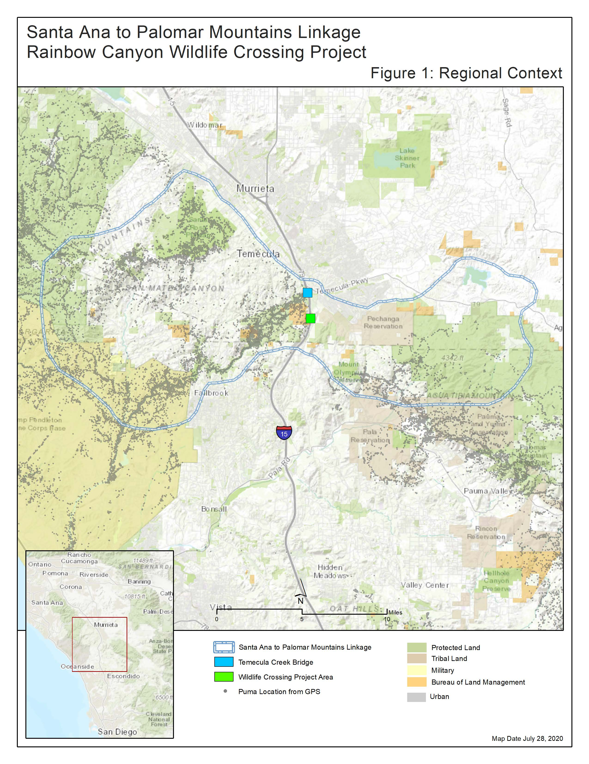**Figure 1: Santa Ana to Palomar Mountains Linkage Rainbow Canyon Wildlife Crossing Context** Click or tap here to enter text.

**Figure 2: Santa Ana to Palomar Mountains Linkage Cougar Impacts**

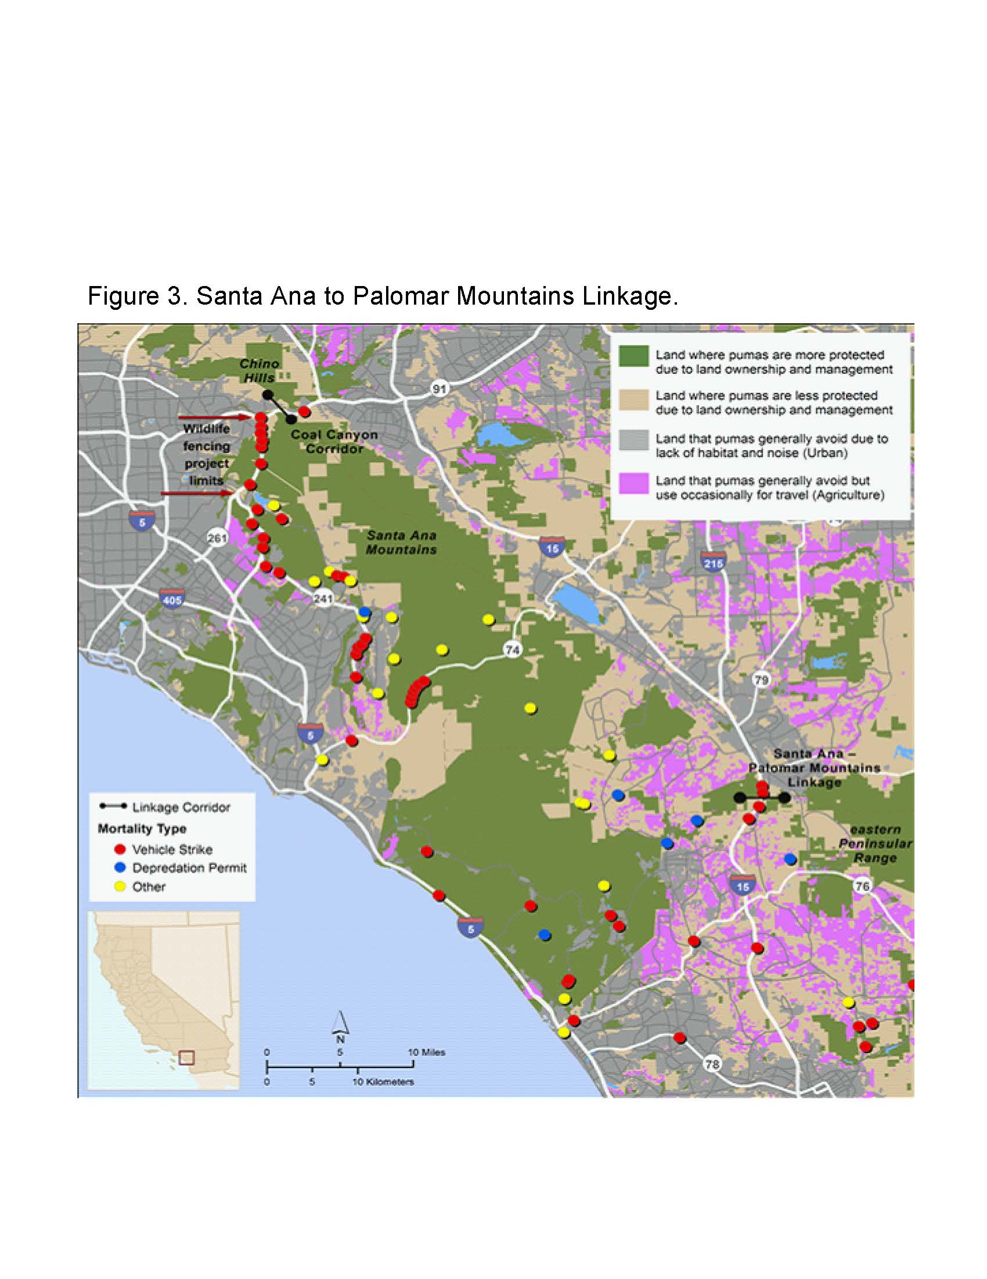

**Figure 3: CDFW Statewide top Priority Connectivity projects (2022) W046**

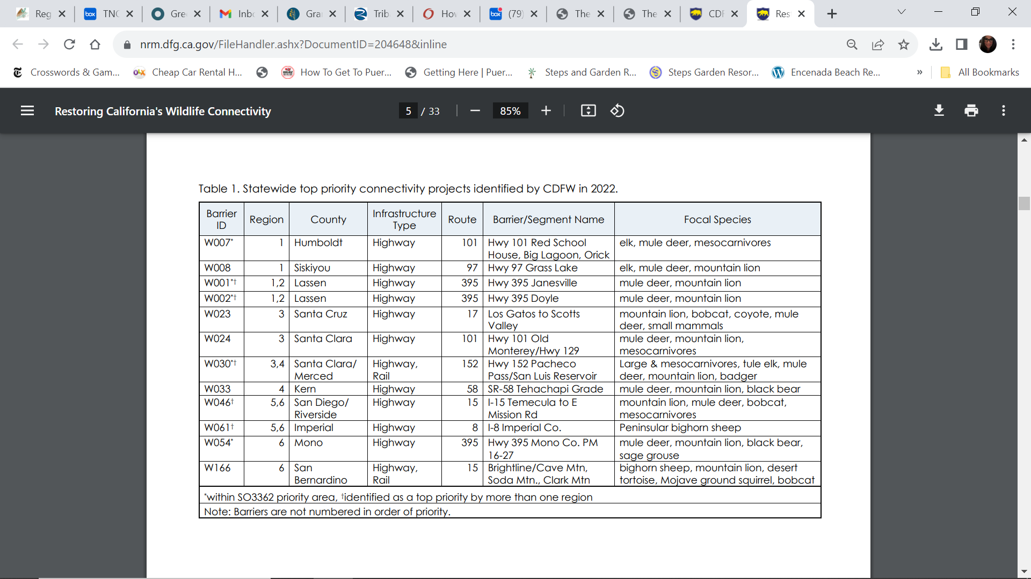

**Figure 4: Santa Ana to Palomar and Rainbow Canyon Wildlife Crossing Workshop, Education and Outreach and Media Touchpoints**

The Interstate-15 Rainbow Canyon Wildlife Crossing Project was advanced through the Caltrans Project Specific Report/Project Initiation Document (PSR/PID) under a previous WCB grant – a significant step forward in the planning and engineering process. In support of this project science and education and outreach has been advanced. This includes bringing together multiple wildlife crossing scientists and crossing experts to identify the best wildlife crossing design for this location, the creation of multiple videos and informational and educational materials as well as podcasts to progress the project and build support. Below is a list of science workshops, reports, projects, videos and media that outline the challenges and the solution to addressing those challenges with wildlife crossings.

1. The Nature Conservancy Connecting California in the Palomar Wildlife Corridor – New Video Release focusing on the significance of the linkage and need for functional wildlife crossings: <https://www.youtube.com/watch?v=m6Rftd3Hw3s>
2. The Nature Conservancy Interstate 15 Wildlife Crossing Design Considerations for Focal Wildlife Species. Santa Ana-Palomar Mountains Linkage Southern California <https://www.scienceforconservation.org/products/interstate-15-wildlife-crossing-design>,
3. TNC Podcast entitled *Destination Nature: A Path for Mountain Lions* <https://www.nature.org/en-us/what-we-do/our-priorities/protect-water-and-land/land-and-water-stories/a-path-for-mountain-lions/> The public can learn about the barrier effects of I-15 and its impact on wildlife and the environment. The podcast underscores the critical importance of the proposed wildlife crossing in reconnecting the habitats on both sides of I-15.
4. Caltrans media and outreach: The importance of this Project was consistently broadcast when fencing was installed in 2022 to ensure that wildlife would not be killed on the highway and to enable directional fencing to guide wildlife to the future wildlife crossings. <https://www.youtube.com/watch?v=GIvfq876BdA&feature=youtu.be>
5. In 2019, UC Davis recently released a documentary series called the *California Mountain Lions Project – 8 Part Miniseries* <https://camountainlions.com/> that promotes the importance of reconnecting the Santa Ana Mountains with the Eastern Peninsular Ranges across I-15.
6. Additional information includes:
   * + <https://www.nature.org/en-us/what-we-do/our-priorities/protect-water-and-land/land-and-water-stories/a-path-for-mountain-lions/>
     + <https://storymaps.arcgis.com/stories/e38463af757240b886365aff17661163>
     + <https://www.nature.org/en-us/about-us/where-we-work/united-states/california/stories-in-california/climate-solutions/>
     + <https://dot.ca.gov/-/media/dot-media/programs/risk-strategic-management/documents/mile-marker/mm-2019-q2-wildlife-crossing-a11y.pdf>
     + <https://www.nature.org/en-us/about-us/where-we-work/united-states/california/stories-in-california/climate-change-resilience/>
     + <https://camountainlions.com/>

**References Cited**

Smith et al. 2023. *Interstate 15 Wildlife Crossing Design Considerations for Focal Wildlife Species. Santa Ana-Palomar Mountains Linkage Southern California*. Final report. The Nature Conservancy California Conservation Science, Sacramento, CA, USA. <https://www.scienceforconservation.org/products/interstate-15-wildlife-crossing-design>

Beier, P., and R. Barrett. 1993. The cougar in the Santa Ana Mountain Range, California. *Final report. Orange County Cooperative Mountain Lion Study, Department of Forestry and Resource Management*. University of California, Berkeley, USA.

Benson, J.F., Mahoney, P.J., Wickers, T. W. et al. 2019. *Extinction vortex dynamics of top predators isolated by urbanization*. Ecological Applications. 29

California Roadkill Observation System. 2022. <https://www.wildlifecrossing.net/california/>

California Department of Fish and Wildlife. 2022. *Restoring California’s Wildlife Connectivity 2022*. Biogeographic Data Branch, Sacramento, California.

California Department of Transportation (Caltrans). 2010. *California Essential Habitat*  *Connectivity Project: A Strategy for Conserving a Connected California*. Sacramento, CA.

Cal Poly Pomona. 2019. I-15 Wildlife Crossings, *Design for I-15. California Polytechnic State University, Pomona*. Department of Civil Engineering. Senior Project 2018-2019.

Center for Biological Diversity, Mountain Lion Foundation (CBD). 2019. *A Petition to List the Southern California/Central Coast Evolutionarily Significant Unit (ESU) of Mountain Lions as Threatened under the California Endangered Species Act (CESA).* Los Angeles, CA.

Clevenger, A. P., and M. Huijser. 2*011. Wildlife crossing structure handbook: design and evaluation in North America*. No. FHWA-CFL/TD-11-003.

County of San Diego, County of Riverside, RCFC&WCD, Cities of Menefee, Temecula, and Wildomar. 2018. *Santa Margarita River Watershed Management Area*. Water Quality Improvement Plan.

Ernest, Holly B., W. Vickers, S. Morrison, M. Buchalski, and W. Boyce. "Fractured Genetic Connectivity Threatens a Southern California Puma (Puma Concolor) Population." PLoS ONE 9, no. 10 (2014).

Gibbons, Philip. “Determining Suitable Wildlife Crossing Locations Across a Southern California Interstate. Final Masters’ Thesis. Department of Geography.” San Diego State University, California, USA. 2008.

Gustafson, K.D., R.B. Gagne, T.W. Vickers, et al. “Genetic source-sink dynamics among naturally structured and anthropogenically fragmented puma populations. Conservation Genetics (2019) 20:215. https://doi.org/10.1007/s10592-018-1125-0

Huijser, Marcel P. PhD and James S. Begley, M.Sc. 2019. *Large Mammal-Vehicle Collision Hot Spot Analyses, California, USA*. Western Transportation Institute, Missoula MT.

Huijser Marcel P. PhD., Ament RJ, Bell M, Clevenger AP, Fairbank ER, Gunson KE, and McGuire T. 2021. *Animal Vehicle Collision Reduction and Habitat Connectivity Study,*  *Literature Review*. Nevada Department of Transportation Research Report 701-18-803 TO 1, Carson City, NV

Luke, Claudia, K. Penrod, C. Cabañero, P. Beier, W. Spencer, and S. Shapiro. “South coast missing linkages project: A linkage design for the Santa Ana—Palomar Mountains connection.” South Coast Wildlands (2004).

Mitelberg, A., Smith, J.G., and Vandergast, A.G., 2019, DNA Fingerprinting of Southern mule deer (Odocoileus hemionus fuliginatus) in north San Diego County, California (2018–19): U.S. Geological Survey Open-File Report 2019– 1138, 25 p., <https://doi.org/10.3133/ofr20191138>.

Penrod, K, R. Hunter, and M. Merrifield. 2001. *Missing Linkages, Restoring Connectivity to the California Landscape*. San Diego, Zoo, San Diego, CA.

Riley, S., T. Smith, and T.W. Vickers. 2018. *Assessment of Wildlife Crossing Sites for the Interstate 15 and Highway 101 Freeways in Southern California*. Final. Available: <https://www.scienceforconservation.org/assets/downloads/SoCalLinkage_Report-2018.pdf>

Riverside County. 2003. Western Riverside Multiple Species Habitat Conservation Plan

Documents. Available: <http://wrc-rca.org/about-rca/multiple-species-habitat-conservation-plan/>

Smith, T., C. Brehme, J. Carpenter, N. Frost, M. Jennings, B. Kus, S. Strahm, T.W. Vickers. 2023. *Interstate 15 Wildlife Crossing Design Considerations for Focal Species in the Santa Ana-Palomar Linkage, Southern California* (in prep).

South Coast Wildlands. 2008. *South Coast Missing Linkages: A wildland network for the south coast ecoregion. Produced in cooperation with partners in the South Coast Missing Linkages Initiative.* Available: <http://www>.scwildlands.org

Spencer, Wayne D., P. Beier, K. Penrod, K. Winters, C. Paulman, H. Rustigian-Romsos, J. Strittholt, M. Parisi, and A. Pettler. "California essential habitat connectivity project: a strategy for conserving a connected California." Prepared for California Department of Transportation, California Department of Fish and Game, and Federal Highways Administration (2010).

Stricker, Kelcey. (2015). The Impact of I-15 on Mammalian Communities in Southern California Conserved Lands. Master's thesis.

The Nature Conservancy. 2022. *Wildlife Crossing Design Considerations for Interstate 15 – Virtual Workshop*. Recording available at: <https://www.youtube.com/watch?v=8mYB97aP1Mc>.

Tracey, Jeff A., J. Zhu, and K. Crooks. 2011. “Modeling and inference of animal movement using artificial

Vickers, T.W., K. Zeller, H. Ernest, K. Gustafson, K. and W. Boyce. Assessment of Mountain Lion Habitat Use and Connectivity in Northern San Diego and Southern Riverside and Orange Counties, with Special Focus on Prioritization of North San Diego County MSCP Lands for Conservation, and Identification of Critical Highway Barriers and Solutions. Prepared for San Diego County Association of Governments and California Department of Fish and Wildlife. (2017).

Vickers, T. W., T. Smith, B. Cohen. 2020. Santa Ana Mountains to eastern Peninsular Range Connectivity Conservation Infrastructure Planning Project for Interstate 15 and Closely Associated Roads. A Joint report to San Diego Area Governments and California Department of Fish and Wildlife. 2020.

Vickers, T.W. 2022.Temecula Creek Wildlife Camera Report. Report for The Nature Conservancy, San Diego, CA.

Wakeling, B.F., J.W. Gagnon, D. Olson, D.W. Lutz, T.W. Keegan, J. Shannon, A. Holland, A. Lindbloom, and C. Schroeder. “Mule Deer and Movement Barriers.” Mule Deer Working Group, Western Association of Fish and Wildlife Agencies, U.S.A. (2015).

Zeller, Katherine A., K. McGarigal, S. Cushman, P. Beier, W. Vickers, and W. Boyce. "Using step and path selection functions for estimating resistance to movement: pumas as a case study." Landscape Ecology (2015): 1-17.